

**VIEN – THE VIRTUAL CONTROLLER**

# A PROJECT REPORT

***Submitted by***

|  |  |
| --- | --- |
| **GNANSEKARAN B** | **510620205011** |
| **GOKUL M** | **510620205012** |
| **YUVARAJ A D** | **510620205052** |

***In partial fulfilment for the award of the degree***

***Of***

**BACHELOR OF TECHNOLOGY**

**IN**

**INFORMATION TECHNOLOGY**

# C.ABDUL HAKEEM COLLEGE OF ENGINEERING AND TECHNOLOGY, MELVISHARAM – 632509

**ANNA UNIVERSITY: CHENNAI – 600025**

JUNE 2024

# BONAFIDECERTIFICATE

Certified that this project report on **VIEN-The Virtual Controller** is the bonafide work of **Gokul M(510620205012), Gnanasekaran B(510620205011), Yuvaraj(510620205052)** ,who carried out the project work under my supervision.

|  |  |
| --- | --- |
| **SIGNATURE**  **Dr. S.UMAMAHESWARI,**  **M.Tech., Ph.D.,**  PROFESSOR  HEAD OF THE DEPARTMENT  Department of Information  Technology,  C. Abdul Hakeem College of Engineering & Technology,  Melvisharam,  Vellore-632509. | **SIGNATURE**  **Dr. S.UMAMAHESWARI,**  **M.Tech., Ph.D.,**  PROFESSOR  HEAD OF THE DEPARTMENT  Department of Information  Technology,  C. Abdul Hakeem College of Engineering & Technology,  Melvisharam,  Vellore-632509. |

Submitted for the university project viva voce to be held on ………………….

|  |  |
| --- | --- |
| ---------------------------------------- | --------------------------------------- |
| **INTERNAL EXAMINER** | **EXTERNAL EXAMINER** |

# ACKNOWLEDGEMENT

# 

Before we get into thick of things, we would like to add a few genuine words for the people who were the part of this project in numerous ways.

We are very thankful to all people whose content constant support and guidance right from the initial stages has enabled us to complete our project successfully.

We first thank to Almighty to who us given the strength and support during course of this project. We express our profound gratitude to our honourable chairman **HAJI Dr. S. ZIAUDDIN AHMED**, B.A., and to our beloved correspondent **HAJI Dr. V.M ABDUL LATHEEF SAHEB**, B.E., F.I.E.

We wish to express our sincere thanks to our respected principal

**Dr. M. SASI KUMAR, Ph.D.,** who has been kind enough to us in all aspects.

We wish to express our heartfelt thanks to our HEAD OF THE DEPARTMENT

**Dr. S**. **UMAMAHESWARI**, Ph.D., and Internal guide

**Dr. S**. **UMAMAHESWARI**, Ph.D.,

And finally our sincere thanks and gratitude to our parents and friends whose constructive criticism made us to analyse deeper and deeper in our project.

## **TABLE OF CONTENTS**

|  |  |  |  |  |
| --- | --- | --- | --- | --- |
| **CHAPTER NO** | **TITLE** | | | **PAGE NO.** |
|  | INDEX PAGE | | | I |
|  | BONAFIDE | | | II |
|  | ACKNOWLEDGEMENT | | | III |
|  | ABSTRACT | | | IV |
|  | TAMIL ABSTRACT | | | VI |
|  | TABLE OF CONTENT | | | VII |
|  | LIST OF FIGURES | | | VIII |
|  | LIST OF ABBREVIATIONS | | | IX |
| 1. | 1.1 | INTRODUCTION | | 1 |
|  |  | 1.1.1 | NAVIGATING THE DIGITAL REALM | 1 |
|  |  | 1.1.2 | SHAPING DYNAMIC PRESENTATIONS | 2 |
|  |  | 1.1.3 | ORCHESTRATING IMMERSIVE AUDIO EXPERIENCES | 2 |
|  |  | 1.1.4 | ADAPTING AMBIENT LIGHTING | 3 |
|  | 1.2 |  | OBJECTIVE | 3 |
|  | 1.3 |  | PROBLEM STATEMENT | 4 |
| 2. | 2.1 |  | LITERATURE SURVEY INTRODUCTION | 5 |
|  |  | 2.1.1 | OPENCV | 6 |
|  |  | 2.1.2 | MEDIAPIPE | 9 |
|  |  | 2.1.3 | PYAUTOGUI | 12 |
|  | 2.2 |  | EXISTING SYSTEM | 16 |
|  |  | 2.2.1 | ADVANTAGES | 17 |
|  |  | 2.2.2 | DISADVANTAGES | 17 |
|  | 2.3 |  | PROPOSED SYSTEM | 18 |
|  |  | 2.3.1 | ADVANTAGES | 20 |
|  |  | 2.3.1 | DISADVANTAGES | 21 |
|  | 2.4 |  | SYSTEM ARCHITECTURE | 21 |
| 3. |  |  | METHODOLOGIES | 22 |
|  | 3.1 |  | HAND DETECTION AND TRACKING | 23 |
|  | 3.2 |  | FEATURE EXTRACTION | 24 |
|  | 3.3 |  | TESTING | 25 |
| 4. | 4.1 |  | DATA FLOW DIAGRAM | 30 |
|  |  | 4.1.1 | DATA FLOW IN THE LEVEL 0 DFD | 33 |
|  |  | 4.1.2 | DATA FLOW IN THE LEVEL 1 DFD | 34 |
|  |  | 4.1.3 | DATA FLOW IN THE LEVEL 2 DFD | 37 |
|  | 4.2 |  | UML DIAGRAM | 41 |
|  |  | 4.2.1 | USECASE DIAGRAM | 42 |
|  |  | 4.2.2 | CLASS DIAGRAM | 44 |
|  |  | 4.2.3 | ACTIVITY DIAGRAM | 46 |
|  |  | 3.2.4 | SEQUENCE DIAGRAM | 50 |
|  |  | 4.2.5 | OBJECT DIAGRAM | 53 |
|  |  | 4.2.6 | COMPONENT DIAGRAM | 55 |
|  |  | 4.2.7 | DEPLOYMENT DIAGRAM | 56 |
|  |  | 4.2.8 | PACKAGE DIAGRAM | 58 |
| 5. |  |  | EXPERIMENT ANALYSIS AND RESULT | 59 |
|  |  | 5.1 | SOFTWARE REQUIREMENTS | 59 |
|  |  | 5.2 | HARDWARE REQUIREMENTS | 59 |
|  |  | 5.3 | SCREENSHOT OF RESULTS | 59 |
| 6. |  |  | CONCLUSION AND FUTURESCOPE | 60 |
|  |  |  | REFERENCE | 62 |
|  |  |  | APPENDIX | 63 |

## **ABSTRACT**

The emergence of gesture control systems using cameras has revolutionized human-computer interaction by enabling devices to interpret and respond to natural human gestures without the need for physical touch or traditional input methods. In this study, we present a method for controlling a computer's cursor position solely through hand gestures captured by a camera, thereby eliminating the need for any additional electronic equipment. The proposed Virtual Mouse system serves as an intermediary between the user and the computer, leveraging computer vision techniques implemented with OpenCV and Python to process the camera's output in real-time. Through the analysis of the video feed, predefined gestures are recognized and translated into corresponding cursor movements, providing users with an intuitive and hands-free means of interacting with their devices. The system offers a flexible infrastructure that can be further calibrated according to user preferences and environmental factors. This innovative technology opens doors to a wide range of applications, including presentations, hands-free device control, and accessibility enhancements, thereby enhancing user experience and usability in various domains.

**சுருக்கம்**

**கேமராக்களைப் பயன்படுத்தி சைகை கட்டுப்பாட்டு அமைப்புகளின் தோற்றம் மனித-கணினி தொடர்புகளில் புரட்சியை ஏற்படுத்தியுள்ளது, இதன் மூலம் உடல் தொடுதல் அல்லது பாரம்பரிய உள்ளீட்டு முறைகள் தேவையில்லாமல் இயற்கையான மனித சைகைகளை விளக்குவதற்கும் பதிலளிக்கவும் சாதனங்களை செயல்படுத்துகிறது. இந்த ஆய்வில், கேமராவால் கைப்பற்றப்பட்ட கை சைகைகள் மூலம் மட்டுமே கணினியின் கர்சரின் நிலையைக் கட்டுப்படுத்தும் முறையை நாங்கள் முன்வைக்கிறோம், இதன் மூலம் கூடுதல் மின்னணு சாதனங்களின் தேவையை நீக்குகிறது. முன்மொழியப்பட்ட விர்ச்சுவல் மவுஸ் அமைப்பு பயனருக்கும் கணினிக்கும் இடையே ஒரு இடைத்தரகராக செயல்படுகிறது, கேமராவின் வெளியீட்டை நிகழ்நேரத்தில் செயலாக்க OpenCV மற்றும் Python உடன் செயல்படுத்தப்பட்ட கணினி பார்வை நுட்பங்களை மேம்படுத்துகிறது. வீடியோ ஊட்டத்தின் பகுப்பாய்வின் மூலம், முன் வரையறுக்கப்பட்ட சைகைகள் அங்கீகரிக்கப்பட்டு தொடர்புடைய கர்சர் இயக்கங்களுக்கு மொழிபெயர்க்கப்படுகின்றன, பயனர்களுக்கு அவர்களின் சாதனங்களுடன் தொடர்புகொள்வதற்கான உள்ளுணர்வு மற்றும் ஹேண்ட்ஸ்-ஃப்ரீ வழிமுறைகளை வழங்குகிறது. பயனர் விருப்பத்தேர்வுகள் மற்றும் சுற்றுச்சூழல் காரணிகளுக்கு ஏற்ப மேலும் அளவீடு செய்யக்கூடிய நெகிழ்வான உள்கட்டமைப்பை இந்த அமைப்பு வழங்குகிறது. இந்த புதுமையான தொழில்நுட்பம், விளக்கக்காட்சிகள், ஹேண்ட்ஸ்-ஃப்ரீ சாதனக் கட்டுப்பாடு மற்றும் அணுகல்தன்மை மேம்பாடுகள் உள்ளிட்ட பல்வேறு வகையான பயன்பாடுகளுக்கு கதவுகளைத் திறக்கிறது, இதன் மூலம் பயனர் அனுபவத்தையும் பல்வேறு களங்களில் பயன்பாட்டினை மேம்படுத்துகிறது.**

**LIST OF FIGURES**

System Workflow 1

* 1. Block Diagram 2
  2. System Architecture 21
  3. Usecase Diagram 42
  4. Class Diagram 44
  5. Activity Diagram 46
  6. Sequence Diagram 50
  7. Object Diagram … 53
  8. Component Diagram 55
  9. Deployment Diagram 56
  10. Package Diagram 58
  11. Screenshot Of Results 59

## **LIST OF ABBREVIATIONS**

|  |  |
| --- | --- |
| DFD | Data Flow Diagram |
| OPENCV | Open Source Computer Vision Library |
| HMMs | Hidden Markov Models |
| CNNs | Convolutional Neural Networks |
| SVMs | Support Vector Machines |
| GPU | Graphics Processing Unit |

**CHAPTER – 1**

## INTRODUCTION

In the ever-expanding tapestry of human-computer interaction, the convergence of technology and gestures has unlocked new dimensions of control and expression. From the subtle flick of a wrist to the sweeping arc of a hand, gestures offer an intuitive language through which we interact with the digital world. In this expert introduction, we embark on a journey into the realm of hand gesture control, exploring its transformative potential in navigating the digital landscape, shaping presentations, orchestrating audio experiences, and adjusting screen brightness with effortless finesse.

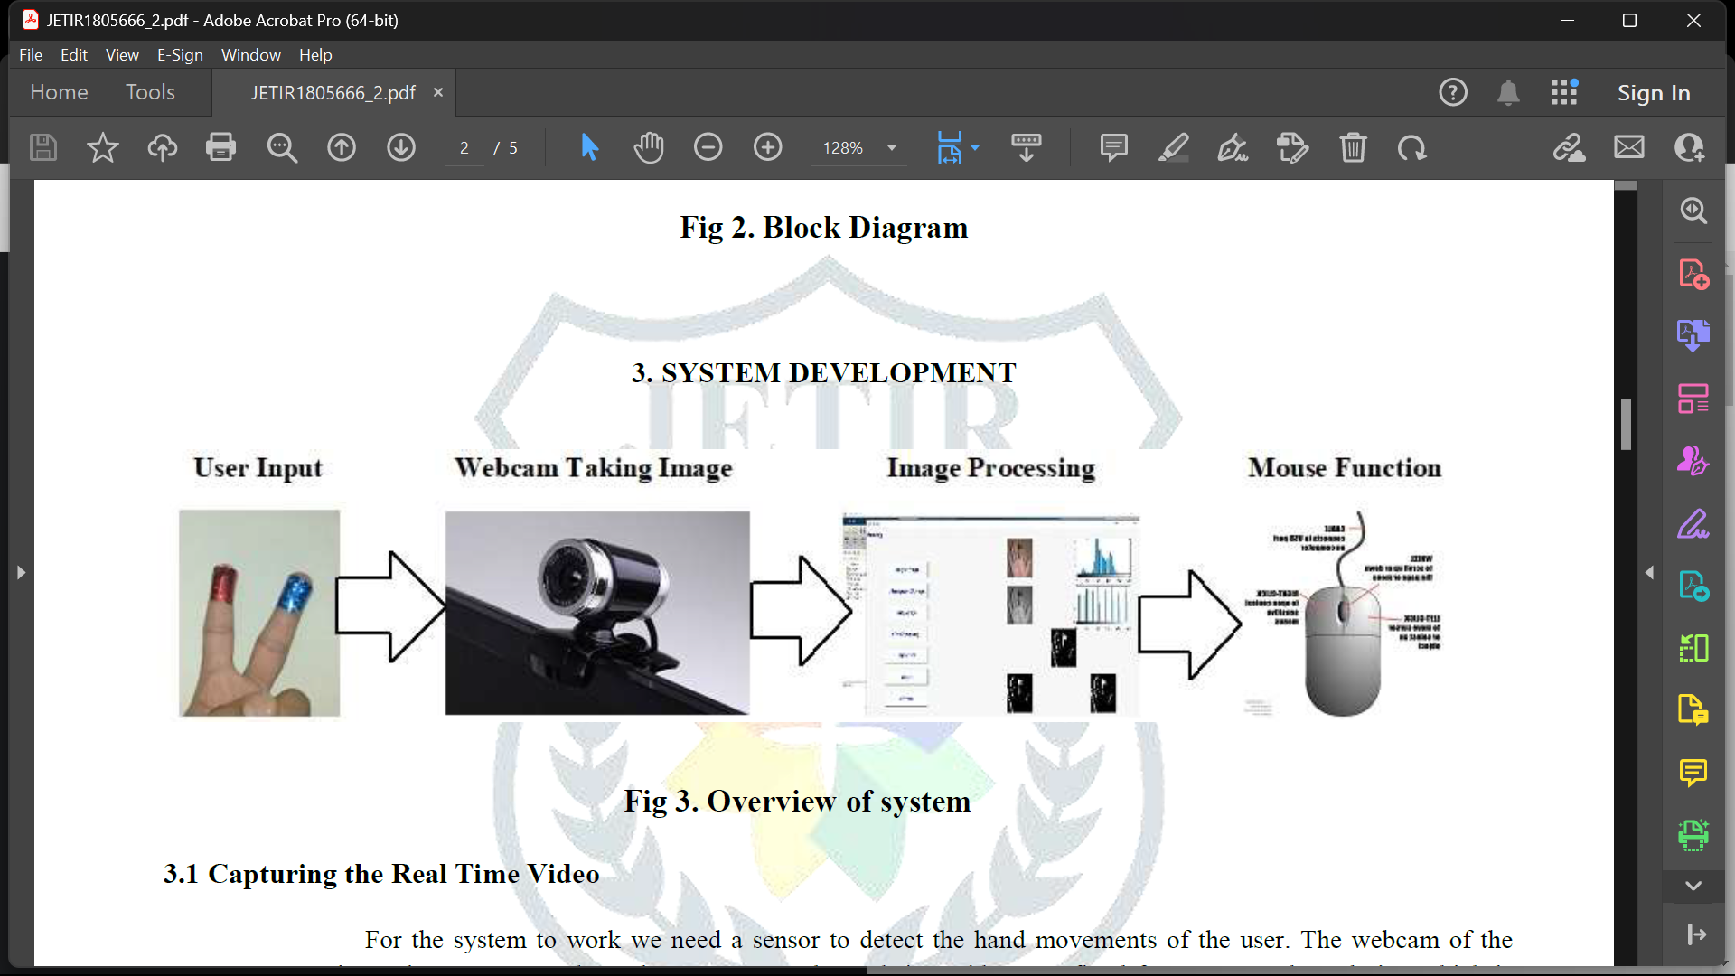

* + 1. Navigating the Digital Realm:

Imagine a world where the mouse becomes an extension of your hand, responding effortlessly to your slightest movements. Hand gesture control offers precisely that - a seamless means of navigating digital interfaces with natural gestures. Through the integration of computer vision, machine learning, and sensor technologies, hand gestures become potent tools for manipulating cursors, clicking, scrolling, and dragging with unparalleled precision and fluidity. By transcending the constraints of traditional input devices, gesture-based navigation opens new pathways to efficiency and creativity in computing.

* + 1. Shaping Dynamic Presentations:

In the realm of presentations, gestures become the conductor's baton, orchestrating a symphony of visual and auditory elements with graceful motions. With hand gesture control, presenters can seamlessly navigate slides, zoom in on details, and emphasize key points with intuitive gestures. Whether commanding attention with a sweeping gesture or zooming in for a closer look with a pinch, the presenter's movements become a choreography of engagement, captivating audiences and enhancing communication in the digital realm.

* + 1. Orchestrating Immersive Audio Experiences:

In the realm of audio, gestures transcend the boundaries of physical controls, offering a tactile means of sculpting soundscapes with finesse. Through hand gesture control, users can adjust volume, skip tracks, and toggle playback with effortless gestures, transforming the act of listening into a dynamic and interactive experience. Whether conducting a virtual orchestra or fine-tuning the balance of audio elements, gestures imbue music and sound with a newfound sense of fluidity and expression.

* + 1. Adapting Ambient Lighting:

In the realm of visual comfort, gestures offer a seamless means of adjusting screen brightness to suit the ambient environment. Hand gesture control enables users to effortlessly modulate screen brightness with subtle gestures, ensuring optimal visibility and reducing eye strain in varying lighting conditions. From dimming the screen for late-night viewing to boosting brightness for outdoor readability, gestures empower users to tailor their digital experience to their preferences with ease and precision.

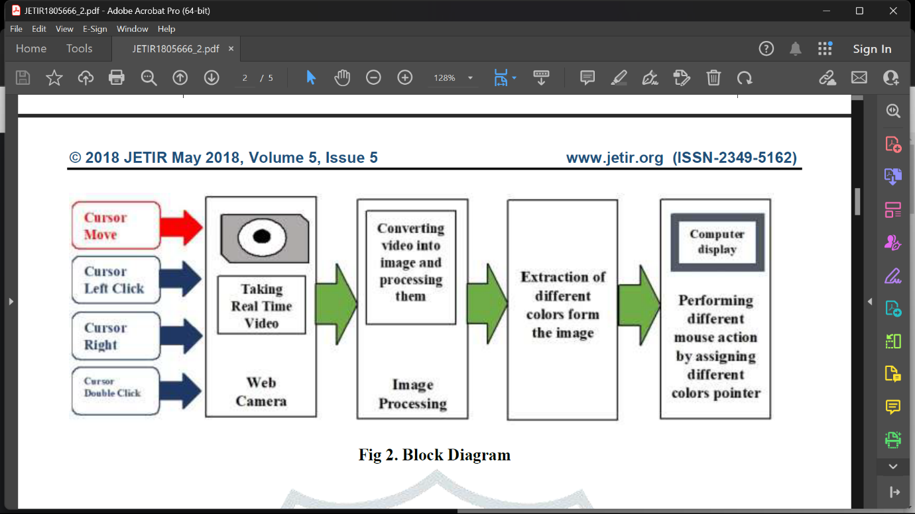

* 1. Objectives:

Develop a robust hand gesture recognition system capable of accurately detecting and interpreting a range of gestures.

Implement functionalities for controlling mouse movements, clicks, and scrolling using hand gestures, providing users with an alternative input method for navigating digital interfaces.

Design an intuitive interface for controlling PowerPoint presentations, enabling users to advance slides, navigate between slides, and perform other presentation-related actions through hand gestures.

Integrate hand gesture controls for audio playback, allowing users to play, pause, skip tracks, adjust volume, and perform other audio-related tasks with natural hand movements.

Implement a feature for adjusting screen brightness based on hand gestures, providing users with a convenient means of adapting display settings to suit their preferences and ambient lighting conditions.

* 1. Problem Statement:

In an era of ever-evolving human-computer interaction, traditional input methods often fall short of meeting the demands for seamless control and intuitive operation. As such, there arises a pressing need for innovative solutions that bridge the gap between users and their digital environments. In response to this challenge, the objective of this project is to develop an expert solution for controlling mouse functions, PowerPoint presentations, audio playback, and screen brightness adjustment using hand gestures.

**CHAPTER – 2**

* 1. Literature Survey Introduction:

Hand gesture recognition has garnered significant attention in recent years as a promising avenue for enhancing human-computer interaction (HCI) through intuitive and natural control mechanisms. By interpreting the intricate movements of the human hand, gesture recognition systems offer a means of bridging the gap between users and digital devices, empowering individuals to interact with technology in a seamless and effortless manner. In the context of controlling mouse functions, PowerPoint presentations, audio playback, and screen brightness adjustment, a thorough literature survey reveals a rich landscape of research efforts, spanning a diverse range of methodologies, applications, and challenges.

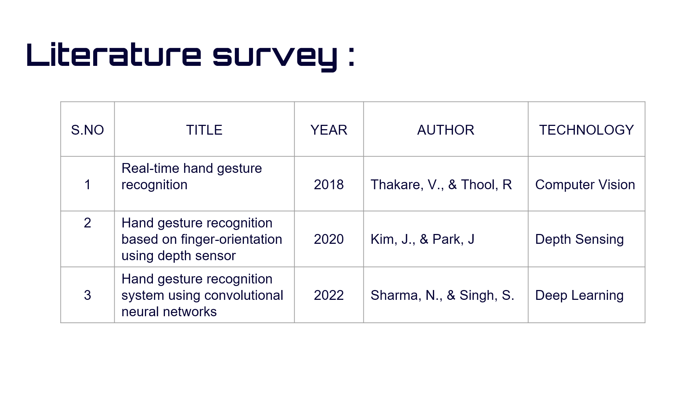

* + 1. OPENCV

Using OpenCV for controlling mouse functions, PowerPoint presentations, audio playback, and screen brightness adjustment through hand gestures involves a combination of computer vision techniques, gesture recognition algorithms, and system integration. Here's an explanation of how OpenCV can be utilized for each aspect of the project:

Begin by installing OpenCV and any necessary dependencies in your Python environment. You can install OpenCV using pip:

code

pip install opencv-python

Hand Detection and Tracking:

OpenCV provides a rich set of tools for detecting and tracking hands in real-time video streams. Techniques such as background subtraction, skin color segmentation, and hand contour detection can be employed to isolate the hand region from the background. OpenCV's cv2.VideoCapture() function can be used to capture video frames from a webcam or another video source, while methods like cv2.findContours() and cv2.convexHull() can be utilized for identifying and tracking the hand contours.

Gesture Recognition:

Once the hand is detected and tracked, gesture recognition algorithms can be applied to interpret hand movements and recognize specific gestures. OpenCV offers functionalities for feature extraction, pattern recognition, and machine learning-based classification, which are essential for building robust gesture recognition models. Techniques such as template matching, histogram of oriented gradients (HOG), and deep learning-based approaches (using frameworks like TensorFlow) can be implemented within the OpenCV framework to classify hand gestures accurately.

Mouse Control:

OpenCV can be used to map recognized hand gestures to mouse functions such as cursor movement, clicking, and scrolling. By capturing the coordinates of the hand centroid or fingertips and translating them into corresponding mouse actions, OpenCV enables users to control the mouse cursor in real-time. The pyautogui library in Python can complement OpenCV by providing functionalities for simulating mouse events such as moveTo(), click(), and scroll().

The realm of mouse control through hand gestures has been a focal point of research, aiming to provide users with an alternative input method for navigating digital interfaces. Traditional approaches have explored techniques such as template matching, optical flow analysis, and hand pose estimation to interpret hand movements and translate them into mouse cursor movements, clicks, and scrolling actions. Recent advancements in deep learning have enabled the development of more robust and accurate gesture recognition models, facilitating real-time interaction with digital environments.

PowerPoint Presentation Control:

Integrating OpenCV with PowerPoint presentations allows users to navigate slides and interact with presentation content using hand gestures. By mapping recognized gestures to keyboard shortcuts or PowerPoint-specific commands, OpenCV enables presenters to advance slides, go back, start/stop presentations, and perform other actions seamlessly. Libraries like pyautogui or pywin32 can be utilized to send keyboard inputs or control PowerPoint via its COM API.

In the domain of presentation control, hand gestures offer a dynamic and engaging means of managing slides, advancing content, and interacting with audiences. Research in this area has explored gesture-based interfaces for controlling PowerPoint presentations, enabling presenters to navigate slides, annotate content, and trigger multimedia elements through intuitive hand movements. Techniques such as hand trajectory analysis, gesture segmentation, and dynamic gesture mapping have been employed to enhance the efficiency and effectiveness of gesture-based presentation systems.

Audio Playback Control:

OpenCV can also be employed for controlling audio playback applications such as music players or multimedia software. By mapping hand gestures to keyboard shortcuts or media control commands, users can play, pause, skip tracks, adjust volume, and perform other audio-related tasks with intuitive hand movements. Libraries like pyautogui or pywin32 can be used to send keyboard inputs or interact with media player applications programmatically.

Hand gesture control also extends to the realm of audio playback, where users can interact with music and multimedia content through expressive gestures. Studies have investigated gesture-based interfaces for controlling audio playback applications, allowing users to play, pause, skip tracks, adjust volume, and perform other audio-related tasks with natural hand movements. Gesture recognition algorithms based on machine learning, including hidden Markov models (HMMs), support vector machines (SVMs), and convolutional neural networks (CNNs), have demonstrated promising results in interpreting a wide range of gestures accurately and reliably.

Screen Brightness Adjustment:

OpenCV-based hand gesture recognition can be integrated with screen brightness adjustment mechanisms to adapt display settings based on user preferences and environmental conditions. By recognizing specific gestures corresponding to brightness adjustment commands, OpenCV enables users to dynamically modulate screen brightness levels with natural hand movements. System-level APIs or libraries such as wmi (for Windows) or screen_brightness_control (for Linux) can be used to adjust screen brightness programmatically.

Adapting to ambient lighting conditions is another area where hand gesture control can enhance user experience, particularly in the context of screen brightness adjustment. Research efforts have explored gesture-based interfaces for dynamically modulating screen brightness based on user preferences and environmental factors. By analyzing hand gestures captured through cameras or depth sensors, systems can automatically adjust screen brightness levels to optimize visibility and reduce eye strain in varying lighting conditions.

Overall, OpenCV serves as a versatile framework for implementing hand gesture recognition systems and integrating them with various applications for controlling mouse functions, PowerPoint presentations, audio playback, and screen brightness adjustment with ease and flexibility.

* + 1. Mediapipe

Implementing a hand gesture recognition project using MediaPipe involves leveraging its robust pose estimation and hand tracking capabilities along with custom gesture recognition models. Here's an in-depth explanation of how to approach such a project:

Setting Up MediaPipe:

Begin by installing the necessary libraries and dependencies for using MediaPipe in your Python environment. You can install MediaPipe using pip:

code

pip install mediapipe

Hand Detection and Tracking:

MediaPipe provides a pre-trained hand tracking model that can detect and track hand landmarks in real-time video streams. You can use this model to localize the hand and track its movement across frames. Import the mediapipe library and load the hand detection model:

python

code

import mediapipe as mp

mp_hands = mp.solutions.hands

hands = mp_hands.Hands()

Gesture Recognition:

Train a custom gesture recognition model using the hand landmarks provided by MediaPipe. Collect a dataset of hand gesture images or video clips and label them with corresponding gesture classes. Use transfer learning or train a custom model from scratch using frameworks like TensorFlow or TensorFlow Lite. You can utilize techniques such as CNNs, RNNs, or attention-based models to classify hand gestures accurately.

Integration with Applications:

Once you have trained your gesture recognition model, integrate it with your target applications such as mouse control, PowerPoint presentation control, audio playback control, or screen brightness adjustment. Use the detected hand landmarks from MediaPipe to feed into your gesture recognition model and map recognized gestures to specific actions in your applications.

Real-Time Feedback:

Provide real-time feedback to users by overlaying visualizations on the video stream using MediaPipe. You can draw bounding boxes around detected hands, visualize hand landmarks, or display recognized gestures directly on the video feed. This feedback enhances user interaction and helps users understand how their gestures are being interpreted.

Optimization and Performance:

Optimize your hand gesture recognition pipeline for real-time performance. Utilize techniques such as model quantization, hardware acceleration, or model pruning to reduce inference latency and improve efficiency. MediaPipe offers support for GPU acceleration and optimized inference on mobile devices, allowing you to deploy your application across a variety of platforms.

User Interface Design:

Design a user-friendly interface for interacting with your application. Provide clear instructions on how to perform gestures and indicate the current state or action being performed based on recognized gestures. Consider incorporating feedback mechanisms such as sound effects or haptic feedback to enhance the user experience.

Testing and Evaluation:

Test your hand gesture recognition system thoroughly across various scenarios and environments to ensure robustness and reliability. Evaluate the performance of your system in terms of gesture recognition accuracy, real-time responsiveness, and user satisfaction. Collect feedback from users and iterate on your design to address any issues or shortcomings.

By following these steps and leveraging the capabilities of MediaPipe, you can develop a sophisticated hand gesture recognition system that offers intuitive and natural interaction with digital applications. Whether controlling a mouse, navigating presentations, adjusting audio playback, or modifying screen brightness, MediaPipe empowers you to create immersive and engaging user experiences.

* + 1. PyAutoGUI

Integrating PyAutoGUI with hand gesture recognition enables full control over various functionalities such as mouse manipulation, keyboard inputs, window management, and more. Here's an expert solution for leveraging PyAutoGUI's functionalities within a hand gesture recognition project:

Mouse Manipulation:

PyAutoGUI offers extensive mouse control capabilities, allowing you to move the cursor, click, drag, scroll, and perform other mouse-related actions programmatically. You can map specific hand gestures to corresponding mouse actions recognized by your gesture recognition system.

For example:

python

Copy code

import pyautogui

# Move the mouse cursor

pyautogui.moveTo(x, y)

# Click the mouse button

pyautogui.click()

# Drag the mouse cursor

pyautogui.dragTo(x, y)

# Scroll the mouse wheel

pyautogui.scroll(amount)

Keyboard Inputs:

PyAutoGUI enables simulation of keyboard inputs, allowing you to send keystrokes, hotkeys, and keyboard shortcuts to control applications. You can map hand gestures to specific keyboard inputs to trigger actions such as opening applications, navigating menus, or entering text.

For example:

python

Copy code

import pyautogui

# Type text

pyautogui.typewrite('Hello, world!')

# Press a single key

pyautogui.press('enter')

# Press a combination of keys (hotkey)

pyautogui.hotkey('ctrl', 'c')

Window Management:

PyAutoGUI provides functions for interacting with windows, including maximizing, minimizing, resizing, and focusing windows. You can use these functions to control the behavior and appearance of applications based on recognized hand gestures.

For example:

python

Copy code

import pyautogui

# Get the position and size of the active window

window_x, window_y, window_width, window_height = pyautogui.getWindowRect()

# Maximize the active window

pyautogui.maximizeWindow()

# Minimize all windows

pyautogui.minimizeAllWindows()

Screen Capture and Image Recognition:

PyAutoGUI allows you to capture screenshots of the screen and perform image recognition to locate specific elements or patterns on the screen. You can use these capabilities to interact with applications based on their visual appearance.

For example:

python

Copy code

import pyautogui

# Capture a screenshot of the screen

screenshot = pyautogui.screenshot()

# Locate an image on the screen

image_location = pyautogui.locateOnScreen('image.png')

Control Flow and Error Handling:

When integrating PyAutoGUI with hand gesture recognition, it's essential to implement robust control flow and error handling mechanisms to ensure reliable and predictable behaviour. Handle exceptions gracefully and implement fallback strategies in case of errors or unexpected behaviour.

By leveraging PyAutoGUI's functionalities within your hand gesture recognition project, you can create a powerful and versatile system capable of controlling various aspects of applications and operating systems through intuitive hand gestures. Whether manipulating the mouse, simulating keyboard inputs, managing windows, or performing screen-based interactions, PyAutoGUI empowers you to automate tasks and enhance user interaction with ease.

* 1. Existing System

The existing system utilizes gesture recognition technology to control various functions across different software applications. Specifically, it allows users to control a media player (presumably for playing music or videos), zoom in and out in maps (likely referring to the web-based version of Google Maps), and play and pause video clips in YouTube. The system likely employs a camera, such as the Creative Intel RealSense SR300, to capture and interpret hand gestures, which are then translated into corresponding commands for the targeted software applications.

We all are aware of the current scenario of controlling computer through hands which require physical activity. Thus, this can be sometimes strainful to people. To operate a simple power point presentation on the PC we use hand movements by being in contact with the optical device. Eg.Clicking the mouse for going to the next slide or using scroll button for zooming in and out. Apart from the PC interaction we also come across the hardships people face while in their homes. For switching on a single tube or fan they have to get up and go to the switch board.

Handicapped people face great difficulties for their routine activities. So why not design a system where the person anywhere in the house can easily operate its electricals without stressing himself/herself.

* + 1. ADVANTAGES

. Hands-Free Operation without any actual contact with the system

. Enhanced Accessibility ( Additional ways to access a single functionality)

### DISADVANTAGES

* Highly strain related work

Without the help of automation day to day work is becoming highly straining. A user needs to operate a mouse with his/her hand. Continuous clicking on mouse can strain fingers which can result in health problems. While in home, a user when far away from the tube/fan has to go to the particular switch board for switching on/off the controls.

* Trouble for physically challenged

Handicapped face the major problem in day to day life and we all are aware of their scenario. Day to day routine without automation gives rise to many problems for them where they are unsuccessful in achieving the controls of home/computer in time. This can be highly frustrating for them.

* Time consuming

Normal execution of our routine activities can be time consuming as compared to same activities performed by gestures.

* Health problems

Constantly working on PC can lead to spine related health issues which are chronic problems and take time to heal. Similarly constant operation of mouse by hand can strain finger muscles.

* 1. Proposed System

Vien is a software application that allows users to control their computer cursor and interact with digital interfaces without physically moving a physical mouse. Virtual PPT control using gestures offers a hands-free and intuitive way to interact with presentations, making it especially useful in situations where traditional input devices like keyboards or mice are not feasible. Switching between modules using audio in Python typically involves using speech recognition libraries to detect specific commands spoken by the user and then executing actions to switch between modules accordingly.

Mouse Control:

The realm of mouse control through hand gestures has been a focal point of research, aiming to provide users with an alternative input method for navigating digital interfaces. Traditional approaches have explored techniques such as template matching, optical flow analysis, and hand pose estimation to interpret hand movements and translate them into mouse cursor movements, clicks, and scrolling actions. Recent advancements in deep learning have enabled the development of more robust and accurate gesture recognition models, facilitating real-time interaction with digital environments.

Audio Playback control:

Hand gesture control also extends to the realm of audio playback, where users can interact with music and multimedia content through expressive gestures. Studies have investigated gesture-based interfaces for controlling audio playback applications, allowing users to play, pause, skip tracks, adjust volume, and perform other audio-related tasks with natural hand movements. Gesture recognition algorithms based on machine learning, including hidden Markov models (HMMs), support vector machines (SVMs), and convolutional neural networks (CNNs), have demonstrated promising results in interpreting a wide range of gestures accurately and reliably.

Powerpoint presentation:

In the domain of presentation control, hand gestures offer a dynamic and engaging means of managing slides, advancing content, and interacting with audiences. Research in this area has explored gesture-based interfaces for controlling PowerPoint presentations, enabling presenters to navigate slides, annotate content, and trigger multimedia elements through intuitive hand movements. Techniques such as hand trajectory analysis, gesture segmentation, and dynamic gesture mapping have been employed to enhance the efficiency and effectiveness of gesture-based presentation systems.

Screen Brightness:

Adapting to ambient lighting conditions is another area where hand gesture control can enhance user experience, particularly in the context of screen brightness adjustment. Research efforts have explored gesture-based interfaces for dynamically modulating screen brightness based on user preferences and environmental factors. By analyzing hand gestures captured through cameras or depth sensors, systems can automatically adjust screen brightness levels to optimize visibility and reduce eye strain in varying lighting conditions.

* + 1. ADVANTAGES
* Provides hands free experience
* Substitutes for some additional hardware devices(Mouse)
* Can be adapted for natural movements
* Convenient with quick and real-time responses
* New functions can be easily added and existing functions can be easily altered or customized(With adequate programming skill)
  + 1. DISADVANTAGES
* Accuracy of the virtual mouse is comparatively less
* User is required to have a stable hand
* Accuracy is dependent on the quality of the webcam
* Too many similar hand gestures can cause in malfunctioning
  1. SYSTEM ARCHITECTURE

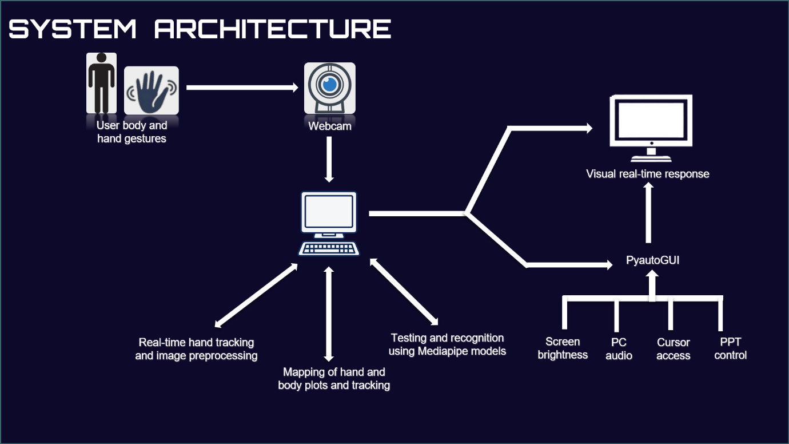

**CHAPTER – 3**

METHODOLOGIES



Data Collection and Preprocessing

Gather a diverse dataset of hand gesture images or video clips, ensuring variability in hand poses, lighting conditions, and backgrounds.

Preprocess the dataset by standardizing image sizes, applying augmentation techniques (e.g., rotation, scaling, flipping), and normalizing pixel values to enhance model generalization.

Data Collection:

Diverse Dataset:

Gather a diverse dataset that covers various hand gestures, hand poses, lighting conditions, backgrounds, and skin tones. This diversity ensures that the model learns to recognize gestures effectively under different circumstances.

Annotation:

Annotate the dataset with labels corresponding to different hand gestures. Each image or video frame should be labeled with the correct gesture to facilitate supervised learning.

Quantity and Quality:

Collect a sufficient number of samples for each gesture to ensure balanced class distribution. The quality of the dataset is also crucial, so ensure that images or frames are captured with sufficient resolution and clarity.

Data Preprocessing:

Normalization:

Normalize the pixel values of images or video frames to a common scale. This ensures that variations in brightness and contrast across different images do not affect model performance disproportionately.

Resizing:

Standardize the size of images or video frames to a fixed resolution. Resizing ensures consistency in input dimensions and simplifies model training.

* 1. Hand Detection and Tracking

Utilize computer vision techniques (e.g., background subtraction, skin color segmentation) or deep learning models (e.g., MediaPipe) to detect and localize hands in real-time video streams.

Implement algorithms for hand landmark detection and tracking to extract key points representing hand positions, orientations, and movements over time.

Hand Detection:

Objectives: The goal of hand detection is to identify and localize regions in an image or video frame that contain human hands.

Techniques:

Traditional Methods:

Traditional computer vision techniques such as background subtraction, skin color segmentation, and template matching can be used for hand detection. These methods rely on handcrafted features and heuristics to differentiate hands from the background.

Hand Tracking:

Objectives: After detecting hands in an initial frame, hand tracking aims to follow their movement across subsequent frames in a video stream.

Techniques:

Keypoint Tracking:

Hand tracking involves identifying and tracking key points or landmarks on the hand, such as fingertips, knuckles, and palm center. Tracking algorithms predict the positions of these keypoints in successive frames based on motion estimation and temporal coherence.

Integration with Gesture Recognition:

Once hands are detected and tracked, the resulting hand trajectories or keypoint sequences can be used as input for gesture recognition algorithms.

* 1. Feature Extraction

Extract relevant features from hand landmarks, such as spatial coordinates, angles, distances between keypoints, and motion trajectories.

Spatial Features:

Hand Landmarks:

Extract spatial coordinates of key points or landmarks on the hand, such as fingertips, knuckles, palm center, and finger joints. These coordinates represent the spatial configuration of the hand and provide information about hand shape and posture.

Hand Region:

Define regions of interest (ROIs) around the hand or specific hand segments (e.g., fingers, palm). Calculate features such as area, aspect ratio, bounding box dimensions, or convex hull properties to characterize the spatial extent and shape of the hand.

Shape Features:

Hand Shape Descriptor: Represent the overall shape of the hand using shape descriptors such as Fourier descriptors, Hu moments, or Zernike moments. These descriptors encode global shape properties and can capture variations in hand shape across different gestures.

Local Shape Descriptors: Describe the shape of specific hand regions or contours using local descriptors like curvature, angle histograms, or chain codes. These descriptors capture finer details of hand shape and structure.

* 1. TESTING

The purpose of testing is to discover errors. Testing is a process of trying to discover every conceivable fault or weakness in a work product.

It provides a way to check the functionality of components, sub assemblies, assemblies and/or a finished product. It is the process of exercising software with the intent of ensuring that the software system meets its requirements and user expectations and does not fail in an unacceptable manner.

Software testing is an important element of the software quality assurance and represents the ultimate review of specification, design and coding. The increasing feasibility of software as a system and the cost associated with the software failures are motivated forces for well planned through testing.

**Testing Objectives:**

There are several rules that can serve as testing objectives they are:

* Testing is a process of executing program with the intent of finding an error.
* A good test case is the one that has a high probability of finding an undiscovered error.

**Types of Testing:**

In order to make sure that the system does not have errors, the different levels of testing strategies that are applied at different phases of software development are :

**Unit Testing:**

Unit testing is done on individual models as they are completed and becomes executable. It is confined only to the designer's requirements. Unit testing is different from and should be preceded by other techniques, including:

* Inform Debugging
* Code Inspection

### **Black Box testing:**

In this strategy some test cases are generated as input conditions that fully

execute all functional requirements for the program.

This testing has been used to find error in the following categories: Incorrect or missing functions

* Interface errors
* Errors in data structures are external database access
* Performance error
* Initialization and termination of errors
* In this testing only the output is checked for correctness
* The logical flow of data is not checked

### **White Box testing**

In this the test cases are generated on the logic of each module by drawing flow graphs of that module and logical decisions are tested on all the cases.

It has been used to generate the test cases in the following cases:

* Guarantee that all independent paths have been executed
* Execute all loops at their boundaries and within their operational bounds.
* Execute internal data structures to ensure their validity.

### **Integration Testing**

Integration testing ensures that software and subsystems work together a whole. It test the interface of all the modules to make sure that the modules behave properly when integrated together. It is typically performed by developers, especially at the lower, module to module level. Testers become involved in higher levels

### **System Testing**

Involves in house testing of the entire system before delivery to the user. The aim is to satisfy the user the system meets all requirements of the client‘s specifications. It is conducted by the testing organization if a company has one. Test data may range from and generated to production.

Requires test scheduling to plan and organize:

1. Scope of Testing: System testing encompasses testing the integrated system as a whole, ensuring that all components work together seamlessly to achieve the desired functionality. This includes testing both functional and non-functional aspects of the system.

2. Objective: The primary goal of system testing is to confirm that the system meets the specified requirements and behaves as expected in its intended environment. It aims to identify defects or deviations from requirements that may have been missed during earlier stages of development.

3. Testing by the Testing Organization: System testing is typically conducted by a dedicated testing organization within the company (if available) or by the development team. This ensures an independent evaluation of the system's readiness for deployment.

4. Test Data Preparation: Test data is crucial for system testing. It includes a comprehensive set of input values, both valid and invalid, to assess the system's response under various conditions. Test data should be carefully designed to cover all scenarios outlined in the requirements.

5. Test Scheduling and Planning:

- Inclusion of Changes/Fixes: System testing often occurs after integration testing and may involve the inclusion of recent changes or fixes made to the system based on earlier testing phases.

- Selection of Test Data: Test data selection and generation should be planned to ensure adequate coverage of test scenarios. This involves identifying relevant test cases and preparing corresponding test data sets.

6. Execution and Reporting: During system testing, test cases are executed, and the system's behavior is observed and recorded. Any issues identified are documented and reported to the development team for resolution.

7. Test Environment Setup: A stable and representative test environment is essential for effective system testing. This environment should closely mirror the production environment to simulate real-world conditions.

8. Types of Tests: System testing may include various types of tests such as functional testing, usability testing, performance testing, security testing, and more, depending on the system's requirements and complexity.

**CHAPTER – 4**

DESIGN

* 1. DATA FLOW DIAGRAM

The DFD is also known as bubble chart. It is a simple graphical formalism that can be used to represent a system in terms of the input data to the system, various processing carried out on these data, and the output data is generated by the system. It maps out the flow of information for any process or system, how data is processed in terms of inputs and outputs. It uses defined symbols like rectangles, circles and arrows to show data inputs, outputs, storage points and the routes between each destination. They can be used to analyse an existing system or model of a new one. A DFD can often visually ―say‖ things that would be hard to explain in words and they work for both technical and non- technical. There are four components in DFD:

1. External Entity
2. Process
3. Data Flow
4. data Store

1. External Entity:

It is an outside system that sends or receives data, communicating with the system. They are the sources and destinations of information entering and leaving the system. They might be an outside organization or person, a computer system or a business system. They are known as terminators, sources and sinks or actors. They are typically drawn on the edges of the diagram. These are sources and destinations of the system‘s input and output. Representation:

1. Process:

It is just like a function that changes the data, producing an output. It might perform computations for sort data based on logic or direct the dataflow based on business rules. Representation:

1. Data Flow:

A dataflow represents a package of information flowing between two objects in the dataflow diagram, Data flows are used to model the flow of information into the system, out of the system and between the elements within the system.

Representation:

4) Data Store:

These are the files or repositories that hold information for later use, such as a database table or a membership form. Each data store receives a simple label.

A Level 0 Data Flow Diagram (DFD) for the Vien system provides a high-level overview of the major processes and interactions within the system. It illustrates how data (in this case, gestures and commands) flow between different components without delving into the internal workings of each process. Let's elaborate on the components and data flow depicted in the Level 0 DFD:

Components in the Level 0 DFD:

1. User Interaction:

- This component represents the actions and inputs initiated by the user, such as hand gestures and voice commands, to interact with the system.

2. Gesture Recognition:

- The Gesture Recognition process is responsible for capturing and interpreting user gestures, typically using input from a camera (for visual gestures) and potentially a microphone (for voice commands). It identifies specific gestures and converts them into actionable commands.

3. Control System:

- The Control System receives the interpreted gestures and commands from the Gesture Recognition process. It acts as the central processing unit that decides how to translate these gestures into control actions for the computer functions.

4. Computer Functions:

- This component represents the various functions and operations that the system can control based on user gestures. These functions include:

- Adjusting screen brightness levels

- Managing audio playback (e.g., play, pause, volume adjustment)

- Controlling mouse actions (e.g., cursor movement, clicks)

4.1.1 Data Flow in the Level 0 DFD

- User Interaction to Gesture Recognition:

- User interactions, such as hand movements or voice commands, are captured by the Gesture Recognition process through the use of cameras and microphones.

- The Gesture Recognition process analyzes the captured data to recognize specific gestures and commands.

- Gesture Recognition to Control System:

- Interpreted gestures and commands identified by the Gesture Recognition process are transmitted to the Control System.

- The Control System receives this data and determines the appropriate actions to be performed based on the recognized gestures.

- Control System to Computer Functions:

- The Control System sends commands or instructions to the Computer Functions component based on the interpreted gestures.

- These commands are executed by the Computer Functions to perform tasks such as adjusting screen brightness, controlling audio playback, and manipulating mouse actions.

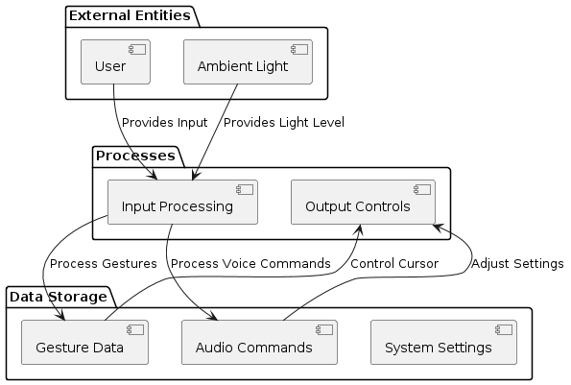

4.1.2 Data Flow in the Level 1 DFD

A Level 1 Data Flow Diagram (DFD) for the Vien system expands upon the Level 0 DFD by breaking down each major process into more detailed subprocesses and data flows. It provides a clearer view of how data moves between components and subprocesses within the system. Let's elaborate on the components and interactions depicted in a Level 1 DFD for Vien:

Components in the Level 1 DFD:

1. User Interaction:

- Represents the user's actions and inputs, including hand gestures and voice commands, which initiate the interaction with the system.

2. Gesture Recognition Subprocess:

- Breaks down the Gesture Recognition process into more detailed steps:

- Capture Video: Captures live video feed from the camera.

- Detect Gestures: Analyzes video frames to detect and recognize gestures.

- Interpret Gestures: Converts detected gestures into actionable commands.

3. Control System:

- Central component that receives interpreted gestures and commands from the Gesture Recognition subprocess and initiates actions in response.

4. Computer Functions Subprocess:

- Represents the specific functions controlled by the system based on interpreted gestures:

- Adjust Screen Brightness: Modifies screen brightness levels based on commands.

- Manage Audio Playback: Controls audio functions such as play, pause, and volume adjustment.

- Control Mouse Actions: Manipulates mouse movements and clicks.

Data Flow in the Level 1 DFD:

- User Interaction to Gesture Recognition Subprocess:

- User interactions (hand gestures, voice commands) initiate the process.

- The system captures video data and detects gestures through the Gesture Recognition subprocess.

- Gesture Recognition Subprocess to Control System:

- Interpreted gestures and commands are forwarded to the Control System from the Gesture Recognition subprocess.

- Control System to Computer Functions Subprocess:

- The Control System sends specific commands to the Computer Functions subprocess based on the interpreted gestures.

- Each subprocess within Computer Functions performs the corresponding task (adjusting screen brightness, managing audio, controlling mouse actions).

Detailed Subprocesses in the Level 1 DFD:

- Gesture Recognition Subprocess:

- Capture Video:

- Inputs: Live video feed from the camera.

- Outputs: Raw video frames.

- Detect Gestures:

- Inputs: Raw video frames.

- Outputs: Identified gestures.

- Interpret Gestures:

- Inputs: Recognized gestures.

- Outputs: Interpreted commands.

- Computer Functions Subprocess:

- Adjust Screen Brightness:

- Inputs: Commands for brightness adjustment.

- Outputs: Updated screen brightness.

- Manage Audio Playback:

- Inputs: Commands for audio control.

- Outputs: Audio playback actions.

- Control Mouse Actions:

- Inputs: Commands for mouse control.

- Outputs: Mouse movements and clicks.

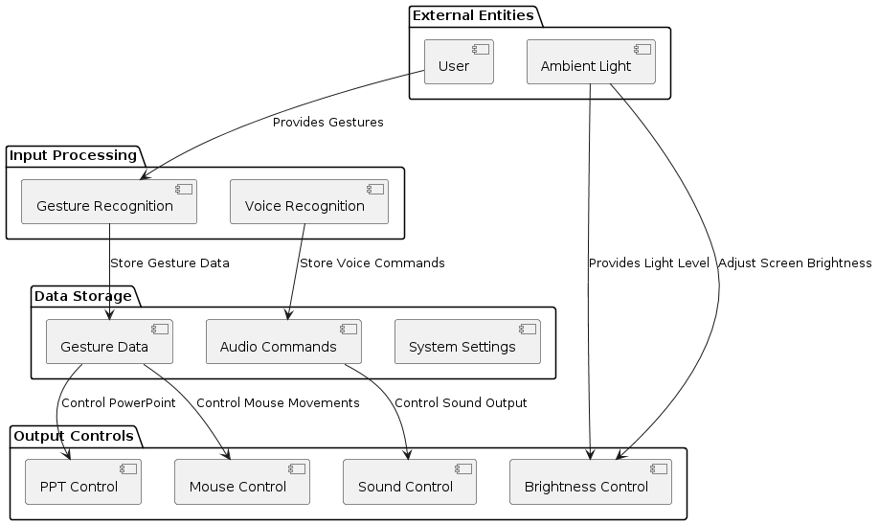

4.1.3 Data Flow in the Level 2 DFD

A Level 2 Data Flow Diagram (DFD) for the Vien system delves even deeper into the subprocesses identified in the Level 1 DFD, providing a more detailed breakdown of each component and the interactions between them. Let's elaborate on the components and interactions depicted in a Level 2 DFD for Vien:

Components in the Level 2 DFD:

1. User Interaction:

- Represents the user's actions and inputs, including hand gestures and voice commands, which initiate the interaction with the system.

2. Gesture Recognition Subprocess:

- Responsible for capturing, detecting, and interpreting gestures from user inputs:

- Capture Video:

- Inputs: Live video feed from the camera.

- Outputs: Raw video frames.

- Detect Gestures:

- Inputs: Raw video frames.

- Outputs: Detected keypoints or gestures.

- Interpret Gestures:

- Inputs: Recognized gestures.

- Outputs: Interpreted commands or actions.

3. Control System:

- Central component that receives interpreted gestures and commands from the Gesture Recognition subprocess and initiates actions in response.

4. Computer Functions Subprocess:

- Represents the specific functions controlled by the system based on interpreted gestures:

- Adjust Screen Brightness:

- Inputs: Commands for brightness adjustment.

- Outputs: Updated screen brightness level.

- Manage Audio Playback:

- Inputs: Commands for audio control.

- Outputs: Actions for audio playback (play, pause, volume adjustment).

- Control Mouse Actions:

- Inputs: Commands for mouse control.

- Outputs: Mouse movements (cursor control, clicks).

Data Flow in the Level 2 DFD:

- User Interaction to Gesture Recognition Subprocess:

- User actions (hand gestures, voice commands) initiate the process.

- The system captures video data and processes it through the Gesture Recognition subprocess to detect and interpret gestures.

- Gesture Recognition Subprocess to Control System:

- Interpreted gestures and commands are transmitted to the Control System from the Gesture Recognition subprocess.

- Control System to Computer Functions Subprocess:

- The Control System sends specific commands to the appropriate Computer Functions subprocess based on the interpreted gestures.

- Each subprocess within Computer Functions performs the corresponding task (adjusting screen brightness, managing audio, controlling mouse actions).

Detailed Subprocesses in the Level 2 DFD:

- Gesture Recognition Subprocess:

- Capture Video:

- Inputs: Live video feed from the camera.

- Outputs: Raw video frames.

- Detect Gestures:

- Inputs: Raw video frames.

- Outputs: Detected keypoints or gestures.

- Interpret Gestures:

- Inputs: Recognized gestures.

- Outputs: Interpreted commands or actions.

- Adjust Screen Brightness Subprocess:

- Receive Command:

- Inputs: Command for brightness adjustment.

- Outputs: Input command.

- Update Screen Brightness:

- Inputs: Command for brightness adjustment.

- Outputs: Updated screen brightness level.

- Manage Audio Playback Subprocess:

- Receive Command:

- Inputs: Command for audio control.

- Outputs: Input command.

- Execute Audio Action:

- Inputs: Command for audio control.

- Outputs: Action performed (play, pause, volume adjustment).

- Control Mouse Actions Subprocess:

- Receive Command:

- Inputs: Command for mouse control.

- Outputs: Input command.

- Perform Mouse Action:

- Inputs: Command for mouse control.

- Outputs: Mouse movement or click action.

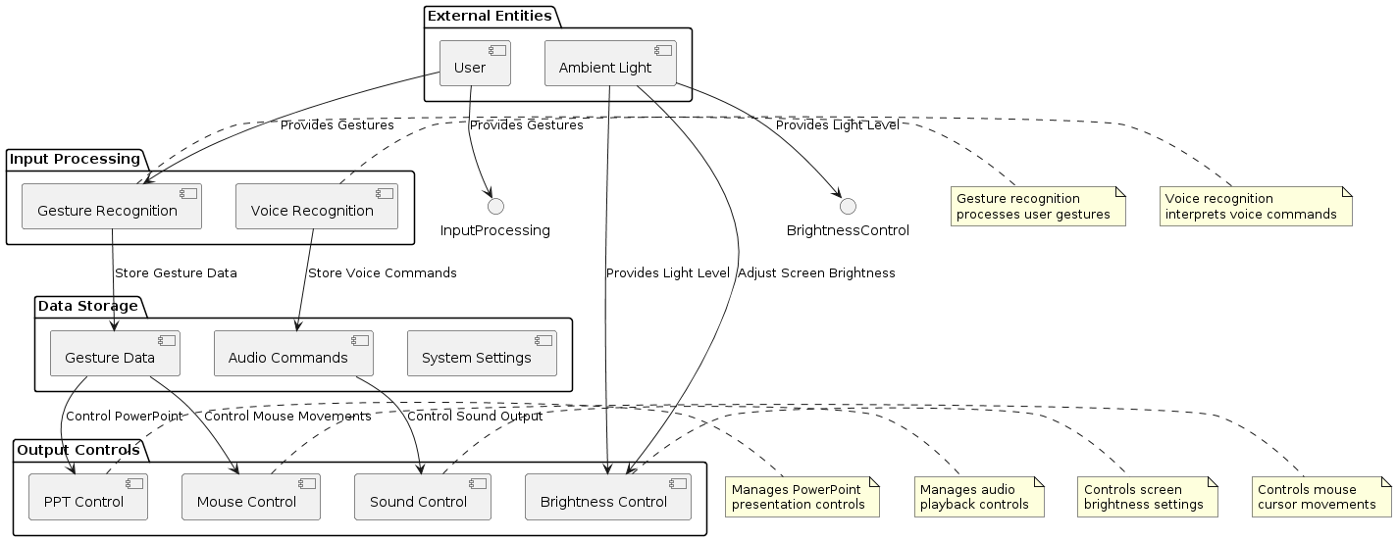

* 1. UML DIAGRAM

UML stands for Unified Modeling Language. Taking SRS document of analysis as input to the design phase drawn UML diagrams. The UML is only language so is just one part of the software development method. The UML is process independent, although optimally it should be used in a process that should be driven, architecture-centric, iterative, and incremental. The UML is language for visualizing, specifying, constructing, documenting the articles in a software- intensive system. It is based on diagrammatic representations of software components.

A modeling language is a language whose vocabulary and rules focus on the conceptual and physical representation of the system. A modeling language such as the UML is thus a standard language for software blueprints.

The UML is a graphical language, which consists of all interesting systems. There are also different structures that can transcend what can be represented in a programming language.

These are different diagrams in UML.

* + 1. USECASE DIAGRAM

Use case describes the behaviour of the system as seen from the actor‘s point of view. It describes the function provided by the system as a set of events that yield a visible result for the actor.

Purpose of Use Case Diagrams

The purpose of use case diagram is to capture the dynamic aspect of a system. functionality of the system. Use case describes a function by the system that yields a visible result for an actor. The identification of actors and use cases result in the definitions of the boundary of the system i.e., differentiating the tasks accomplished by the system and the tasks accomplished by its environment. The actors are outside the boundary of the system, whereas the use cases are inside the boundary of the system.

However, this definition is too generic to describe the purpose, as other four diagrams (activity, sequence, collaboration, and Statechart) also have the same purpose. We will look into some specific purpose, which will distinguish it from other four diagrams.

Use case diagrams are used to gather the requirements of a system including internal and external influences. These requirements are mostly design requirements. Hence, when a system is analyzed to gather its functionalities, use cases are prepared and actors are identified.

When the initial task is complete, use case diagrams are modeled to present the outside view.

In brief, the purposes of use case diagrams can be said to be as follows −

Used to gather the requirements of a system.

Used to get an outside view of a system.

Identify the external and internal factors influencing the system.

Show the interaction among the requirements are actors.

How to Draw a Use Case Diagram?

Use case diagrams are considered for high level requirement analysis of a system. When the requirements of a system are analyzed, the functionalities are captured in use cases.

We can say that use cases are nothing but the system functionalities written in an organized manner. The second thing which is relevant to use cases are the actors. Actors can be defined as something that interacts with the system.

Actors can be a human user, some internal applications, or may be some external applications. When we are planning to draw a use case diagram, we should have the following items identified.

Functionalities to be represented as use case

Actors

Relationships among the use cases and actors.

Use case diagrams are drawn to capture the functional requirements of a system. After identifying the above items, we have to use the following guidelines to draw an efficient use case diagram

The name of a use case is very important. The name should be chosen in such a way so that it can identify the functionalities performed.

Give a suitable name for actors.

Show relationships and dependencies clearly in the diagram.

Do not try to include all types of relationships, as the main purpose of the diagram is to identify the requirements.

Use notes whenever required to clarify some important points.

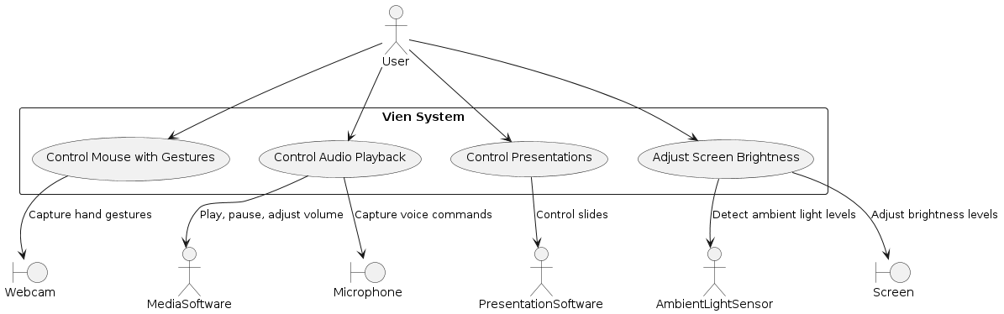

* + 1. CLASS DIAGRAM

Class diagrams model class structure and contents using design elements such as classes, packages and objects. Class diagram describe the different perspective when designing a system-conceptual, specification and implementation. Classes are composed of three things: name, attributes, and operations. Class diagram also display relationships such as containment, inheritance, association etc. The association relationship is most common relationship in a class diagram. The association shows the relationship between instances of classes.

How to Draw a Class Diagram?

Class diagrams are the most popular UML diagrams used for construction of software applications. It is very important to learn the drawinrocedure of class diagram.

Class diagrams have a lot of properties to consider while drawing but here the diagram will be considered from a top level view.

Class diagram is basically a graphical representation of the static view of the system and represents different aspects of the application. A collection of class diagrams represent the whole system.

The following points should be remembered while drawing a class diagram-

The name of the class diagram should be meaningful to describe the aspect of the system.

Each element and their relationships should be identified in advance.

Responsibility (attributes and methods) of each class should be clearly identified

For each class, minimum number of properties should be specified, as unnecessary properties will make the diagram complicated.

Use notes whenever required to describe some aspect of the diagram. At the end of the drawing it should be understandable to the developer/coder.

Finally, before making the final version, the diagram should be drawn on plain paper and reworked as many times as possible to make it correct.

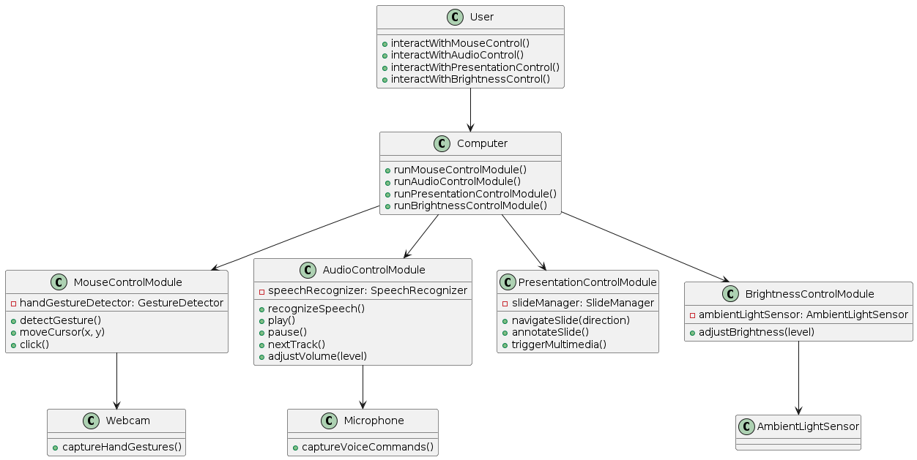

* + 1. ACTIVITY DIAGRAM

An elaboration of a UML (Unified Modeling Language) Activity Diagram for a system like Vien, which involves gesture-based control of computer functions, would focus on visualizing the flow of activities and actions within the system. Let's elaborate on the key components and concepts typically included in such a diagram:

Components of a UML Activity Diagram:

1. Activities:

- Represent specific tasks or actions within the system that are performed sequentially or concurrently.

- Activities are depicted as rounded rectangles with descriptive labels.

2. Transitions:

- Show the flow of control or data between activities.

- Represented by arrows indicating the direction of flow from one activity to another.

3. Decisions (Branches or Decisions):

- Represent decision points where the flow of control diverges based on certain conditions.

- Typically depicted using a diamond-shaped symbol with multiple outgoing paths.

4. Forks and Joins:

- Forks: Represent a point where the control flow splits into multiple concurrent paths.

- Joins: Represent a point where concurrent paths of control merge back into a single path.

5. Initial and Final Nodes:

- Initial Node: Represents the starting point of the activity diagram.

- Final Node: Represents the ending point of the activity diagram or a specific activity.

Elaboration of Activities in Vien System:

1. Capture Video Activity:

- Represents the task of capturing live video feed from the camera.

- Input: Camera device.

- Output: Raw video frames.

2. Detect Gestures Activity:

- Analyzes the captured video frames to detect and recognize hand gestures.

- Input: Raw video frames.

- Output: Detected gestures (e.g., hand movements).

3. Interpret Gestures Activity:

- Translates detected gestures into actionable commands for computer functions.

- Input: Detected gestures.

- Output: Interpreted commands (e.g., adjust brightness, control audio).

4. Adjust Screen Brightness Activity:

- Changes the screen brightness based on commands received from gesture interpretation.

- Input: Command to adjust brightness.

- Output: Updated screen brightness level.

5. Manage Audio Playback Activity:

- Controls audio playback functions (e.g., play, pause, adjust volume) based on interpreted gestures.

- Input: Command for audio control.

- Output: Action performed on audio system.

6. Control Mouse Actions Activity:

- Manipulates mouse movements and actions (e.g., cursor control, clicking) based on gestures.

- Input: Command for mouse control.

- Output: Mouse movement or click action executed.

Flow of Activities in the UML Activity Diagram:

- Start Node: Represents the beginning of the activity diagram.

- Capture Video → Detect Gestures → Interpret Gestures: Sequential flow of activities for gesture recognition and interpretation.

- Decision Point:

- Based on the interpreted gestures (e.g., brightness adjustment command, audio control command), the flow diverges to specific activities (e.g., Adjust Screen Brightness, Manage Audio Playback, Control Mouse Actions).

- Concurrent Activities:

- Activities such as Adjust Screen Brightness, Manage Audio Playback, and Control Mouse Actions can be executed concurrently based on the system's capabilities.

- End Node: Represents the completion of the activity diagram or a specific task within the system.

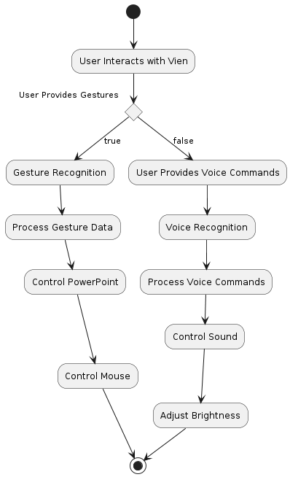

* + 1. SEQUENCE DIAGRAM

Sequence diagram displays the time sequence of the objects participating in the interaction. This consists of the vertical dimension(time) and horizontal dimension (different objects).

Objects: Object can be viewed as an entity at a particular point in time with specific value and as a holder of identity.

A sequence diagram shows object interactions arranged in time sequence. It depicts the objects and classes involved in the scenario and the sequence of messages exchanged between the objects needed to carry out the functionality of the scenario. Sequence diagrams are typically associated with use case realizations in the Logical View of the system under development. Sequence diagrams are sometimes called event diagrams or event scenarios.

A sequence diagram shows, as parallel vertical lines (lifelines), different processes or objects that live simultaneously, and, as horizontal arrows, the messages exchanged between them, in the order in which they occur. This allows the specification of simple runtime scenarios in a graphical manner.

If the lifeline is that of an object, it demonstrates a role. Leaving the instance name blank can represent anonymous and unnamed instances.

Messages, written with horizontal arrows with the message name written above them, display interaction. Solid arrow heads represent synchronous calls, open arrow heads represent asynchronous messages, and dashed lines represent reply messages. If a caller sends a synchronous message, it must wait until the message is done, such as invoking a subroutine. If a caller sends an asynchronous message, it can continue processing and doesn‘t have to wait for a response. Asynchronous calls are present in multithreaded applications, event-driven applications and in message-oriented middleware. Activation boxes, or method-call boxes, are opaque rectangles drawn on top of lifelines to represent that processes are being performed in response to the message (Execution Specifications in UML).

Objects calling methods on themselves use messages and add new activation boxes on top of any others to indicate a further level of processing. If an object is destroyed (removed from memory), an X is drawn on bottom of the lifeline, and the dashed line ceases to be drawn below it. It should be the result of a message, either from the object itself, or another.

A message sent from outside the diagram can be represented by a message originating from a filled-in circle (found message in UML) or from a border of the sequence diagram (gate in UML).

UML has introduced significant improvements to the capabilities of sequence diagrams. Most of these improvements are based on the idea of interaction fragments which represent smaller pieces of an enclosing interaction. Multiple interaction fragments are combined to create a variety of combined fragments, which are then used to model interactions that include parallelism, conditional branches, optional interactions

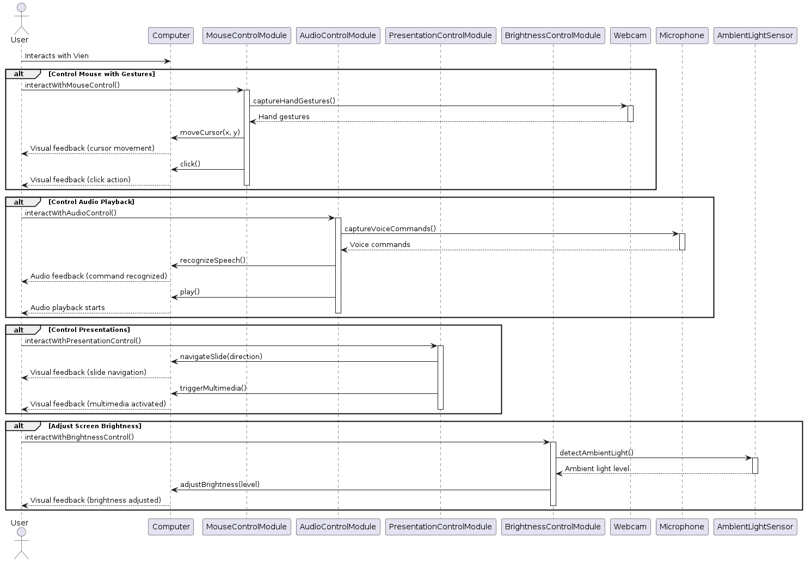

* + 1. OBJECT DIAGRAM

An object diagram indeed provides a snapshot of specific instances of classes and their relationships at a particular moment in time within a system. Here are some key points elaborating on object diagrams and how they differ from class diagrams:

Object Diagram Characteristics:

Instantiation Representation:

An object diagram visually represents instantiated objects (instances) of classes in a system. These objects exist at a specific point in time and capture the state of the system at that instant.

Relationships Between Instances:

Object diagrams illustrate the relationships (associations, aggregations, compositions, etc.) that exist between specific instances of classes. These relationships demonstrate how objects interact with each other within the system.

Snapshot of System State:

By showing instances and their relationships, an object diagram provides a snapshot or static view of the system's behavior at a particular moment. It captures the state of objects and their interactions without depicting dynamic behavior or sequence of events.

Differences from Class Diagrams:

Focus on Instances vs. Classes:

Class diagrams describe the structure and relationships of classes and their members (attributes, methods) in an abstract manner. They define the blueprint for creating objects. In contrast, object diagrams focus on concrete instances of these classes.

Abstract vs. Concrete:

Class diagrams use abstract representations to define the structure and behavior of classes within a system. They serve as a blueprint for creating objects but do not depict specific instances. Object diagrams, on the other hand, depict real instances of classes with their actual attribute values.

Static vs. Dynamic:

Class diagrams are static and represent the class structure at design time. They define the types and relationships of classes. Object diagrams, however, capture the system's state at runtime by showing how instances of these classes are related and interconnected.

Usefulness and Application:

Analysis of System Behavior: Object diagrams are useful for analyzing and understanding the runtime behavior of a system by examining specific instances and their interactions.

Debugging and Testing: They can aid in debugging and testing by visualizing object relationships and verifying the correctness of object instantiation and connections.

Complement to Class Diagrams: Object diagrams complement class diagrams by providing a practical view of how class definitions translate into real objects during system execution.

In summary, object diagrams provide a practical view of instantiated objects and their relationships within a system at a particular moment, offering insights into the system's runtime behavior and object interactions. They serve as a valuable tool for system analysis, design verification, and debugging processes.

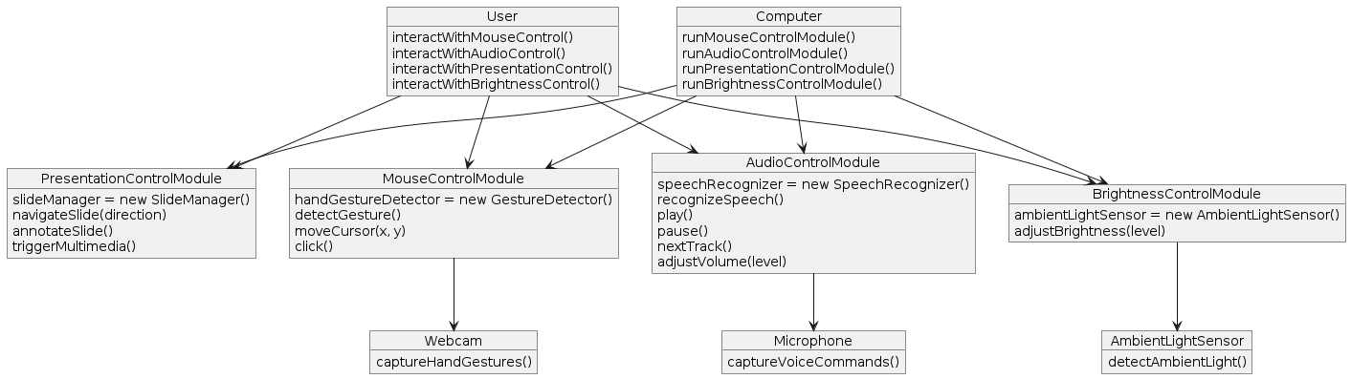

* + 1. COMPONENT DIAGRAM

A component diagram is a type of structural diagram in the Unified Modeling Language (UML) that illustrates the components of a system and the relationships and dependencies between them. It provides a high-level view of the system's architecture, showing how the system is decomposed into smaller, manageable parts or components.

In a component diagram:

Components: Represent the physical or logical units of functionality within a system. Components can be software modules, classes, packages, files, or even hardware devices.

Interfaces: Define the interactions between components. An interface specifies a set of operations or messages that a component can send or receive.

Relationships: Show how components are connected or dependent on each other. This can include dependencies, associations, aggregations, and compositions.

Connectors: Represent the communication channels or dependencies between components. Connectors can be simple lines indicating relationships or can include details such as multiplicity, roles, or stereotypes.

Component diagrams are particularly useful during the design and development phases of software engineering as they help in understanding the structure of the system, organizing and managing complexity, and ensuring that functional requirements are adequately addressed by the planned development. They also serve as a communication tool among stakeholders, providing a visual representation of the system's architecture.

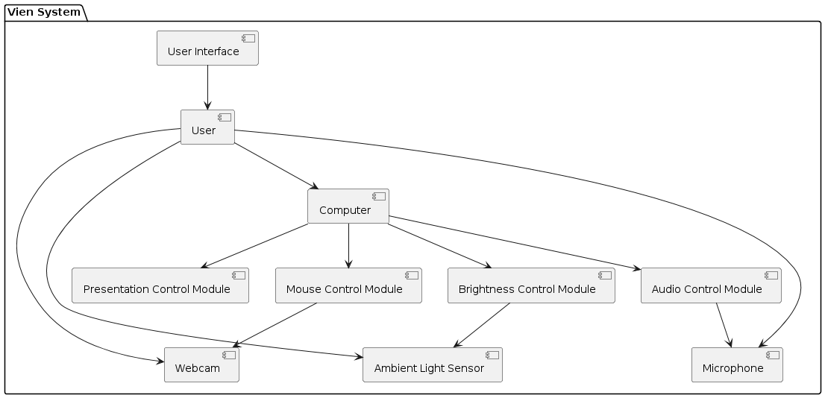

* + 1. DEPLOYMENT DIAGRAM

A deployment diagram is a type of structural diagram in the Unified Modeling Language (UML) used to depict the physical deployment of software components and artifacts on hardware nodes. It provides a visualization of how software components are distributed across various hardware elements in a system architecture.

In a deployment diagram:

Nodes: Represent hardware components such as servers, workstations, routers, or any other computational device where software can be deployed. Nodes are depicted as boxes or rectangles.

Artifacts: Represent software components or files that are deployed on the hardware nodes. These could include executable files, databases, configuration files, libraries, or any other software-related item. Artifacts are typically depicted as rectangles or ovals.

Associations: Show the relationships between nodes and artifacts, indicating which artifacts are deployed on which nodes. These associations illustrate the deployment configuration of the system.

Communication Paths: Depict the communication channels or networks connecting the hardware nodes. This could include network cables, wireless connections, or any other means of communication between nodes.

Deployment diagrams are valuable for system architects, developers, and stakeholders as they provide a clear understanding of how the software components are distributed across the hardware infrastructure. They help in planning, designing, and communicating the deployment architecture of a system, especially in scenarios where software is deployed across multiple machines with different configurations or in distributed environments.

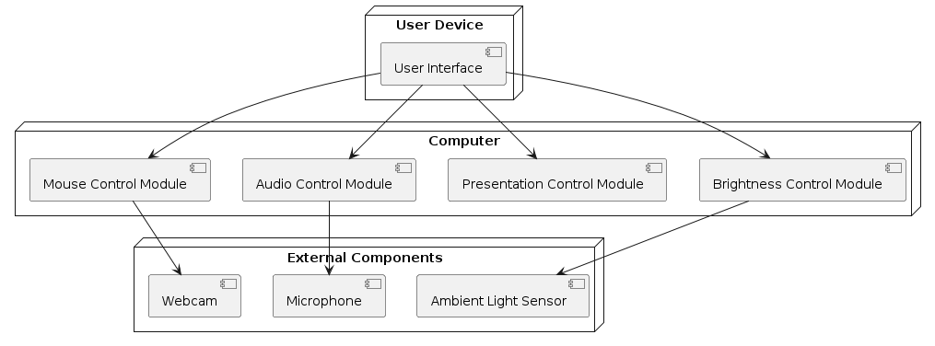

* + 1. PACKAGE DIAGRAM

A package diagram is a type of structural diagram in the Unified Modeling Language (UML) that depicts the organization and dependencies among packages in a software system. Packages are used to group related elements, such as classes, interfaces, or other packages, to manage complexity and improve modularity in software design.

In a package diagram:

Packages: Represent logical groupings of elements within a software system. These can include classes, interfaces, or other packages. Packages are typically depicted as rectangles with the package name displayed at the top.

Dependencies: Arrows between packages indicate dependencies, showing which packages rely on or use other packages. Dependencies can be either directed (with an arrow indicating the direction of dependency) or undirected (without an arrow, indicating a bidirectional dependency).

Contents: The contents of each package are represented within the package boundary. These may include classes, interfaces, enumerations, or other packages. Contents are often depicted using smaller rectangles or ovals within the package rectangle.

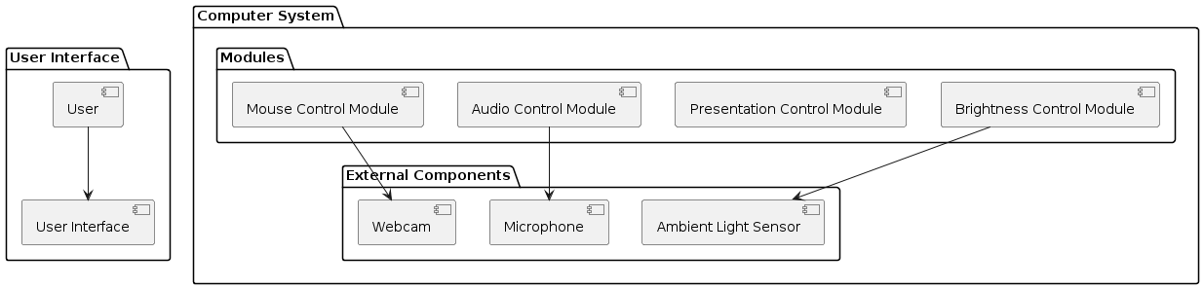

**CHAPTER – 5**

EXPERIMENT ANALYSIS AND RESULTS

* 1. SOFTWARE REQUIREMENTS
* **Window OS**
* **Python interpreter**
* **Required pip files(libraries)**
  1. HARDWARE REQUIREMENTS
* **Basic Laptop or Computer With a Webcam**
  1. SCREENSHOT OF RESULTS

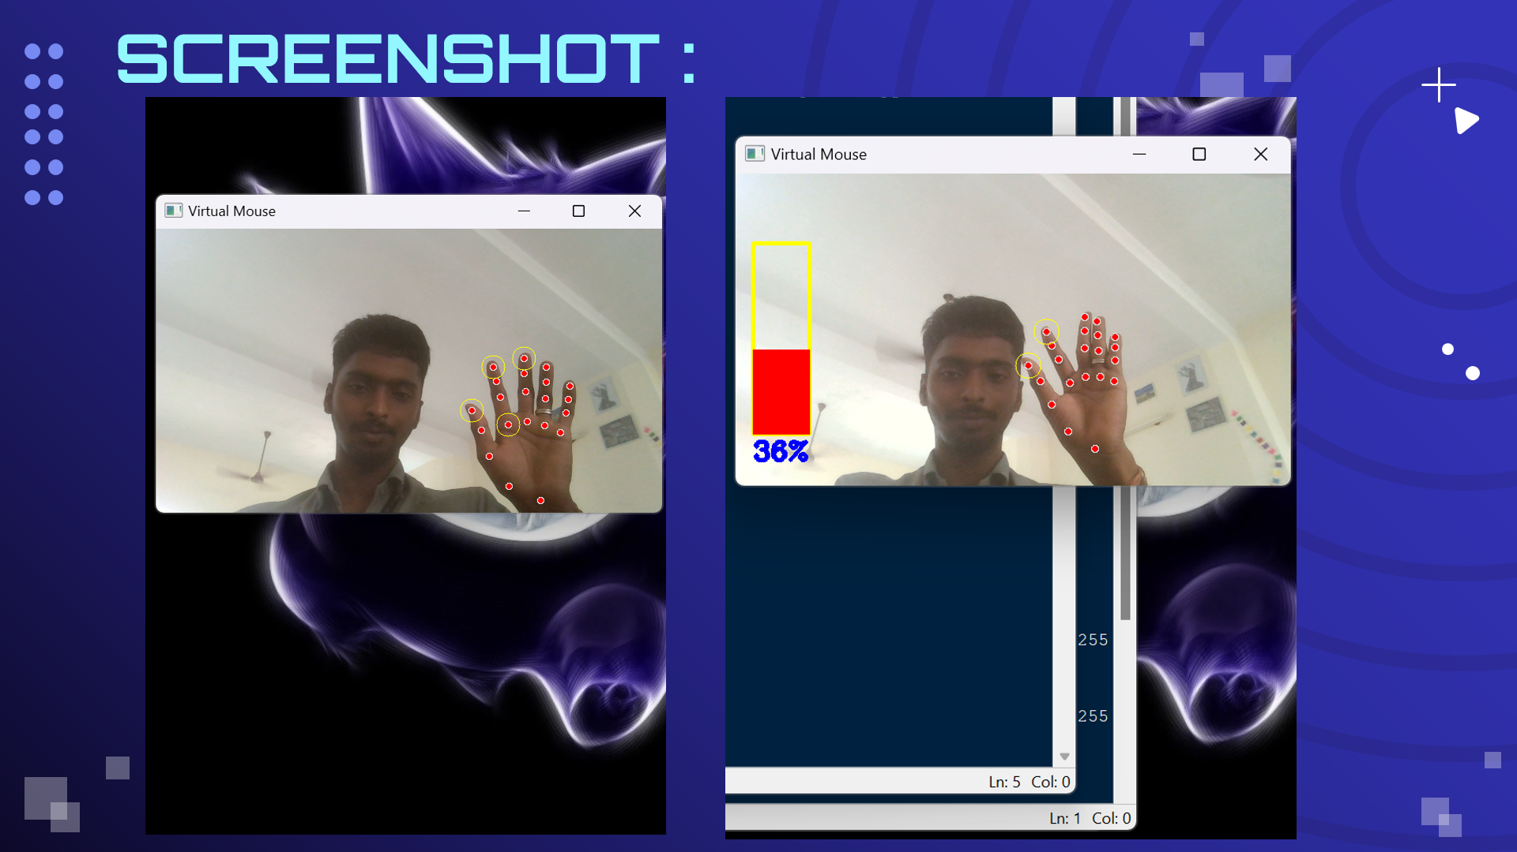

**CHAPTER – 6**

**CONCLUSION AND FUTURESCOPE**

CONCLUSION:

In conclusion, the development of a hand gesture recognition system for controlling mouse, PowerPoint presentations, audio, and screen brightness offers a novel and intuitive interface for interacting with digital devices. By leveraging computer vision techniques and machine learning algorithms, users can seamlessly control various functionalities using natural hand gestures, without the need for physical touch or traditional input methods. This transformative technology not only enhances user experience but also represents a significant step forward in advancing the accessibility and usability of digital interfaces. As we continue to integrate such innovations into everyday technology, the potential for enhanced productivity and engagement becomes increasingly apparent.

**FUTURE SCOPE:**

1. Gesture Control for Camera:

Integrate gesture recognition into the AI assistant's functionality. This can involve recognizing specific gestures (e.g., hand movements) to control the camera, such as zooming, panning, or rotating. Different gestures can trigger specific camera actions, providing an intuitive way to interact with visual content.

1. Sensor Integration:

Use sensors like depth cameras (e.g., Microsoft Kinect) or infrared sensors to enhance the accuracy and responsiveness of gesture recognition. These sensors can provide more detailed information about the user's movements, enabling precise control over the camera or other features based on gestures.

1. Keyboard Control Integration:

Expand the assistant's input methods to include keyboard controls. This can be useful for users who prefer traditional input methods or need precise input for certain tasks. Allow users to map keyboard shortcuts for various assistant functions, enabling faster interaction and control.

1. Voice Commands for Camera Control:

Combine gesture control with voice commands to create a multimodal interaction experience. Users can speak commands like "zoom in" or "move left" alongside gesture inputs, providing flexibility and accessibility in controlling the camera and other features.

1. User Interface Design:

Design an intuitive user interface that displays available gesture and keyboard commands, making it easy for users to learn and remember how to interact with the assistant using different input methods.

1. Feedback and Response:

Implement visual or auditory feedback to confirm the recognition of gestures or keyboard commands. This feedback enhances the user experience by providing reassurance that the assistant has correctly understood and executed the intended actions.

**REFERENCES**

*[1] Prathyakshini, Prathwini (2023). Hand Gesture Controlled Video Player Application.*

DOI:[10.1109/ICECA58529.2023.10395578](https://doi.org/10.1109/ICECA58529.2023.10395578)

*[2] Kirti Aggarwal, Anuja Arora. (2022). An Approach to Control the PC with Hand Gesture Recognition using Computer Vision Technique.*

DOI: [10.23919/INDIACom54597.2022.973282](https://doi.org/10.23919/INDIACom54597.2022.9763282)

*[3] Minu P Abraham, Gaurav Murdeshwar, Divya Jennifer Dsouza. (2022). Gesture Based Hand Control System for Power Point Presentation.*

**DOI:**[10.1109/ICAEECI58247.2023.10370775](https://doi.org/10.1109/ICAEECI58247.2023.10370775)

*[4] Wang Hongpeng, Tan Dianxiong, Wang Jue. (2022). A real-time hand gesture recognition algorithm for an embedded system.*

**DOI:**[10.1109/ICMA.2014.6885817](https://doi.org/10.1109/ICMA.2014.6885817)

*[5]* *Ishwarlal Rathod, Kunal Rathod, Neha Gupta. (2023). Use of IOT in Computer Control Using Hand Gesture Using AT Mega 328 over the Cloud.* **DOI:**[10.1109/ICTBIG59752.2023.10456351](https://doi.org/10.1109/ICTBIG59752.2023.10456351)

*[6] Yande Li, Taiqian Wang, Aamir khan, Lian Li, Caihong Li, Yi Yang, Li Liu. (2018). Hand Gesture Recognition and Real-time Game Control Based on A Wearable Band with 6-axis Sensors.*

**DOI:**[10.1109/IJCNN.2018.8489743](https://doi.org/10.1109/IJCNN.2018.8489743)

**APPENDIX**

MAIN.py

import cv2

import mediapipe as mp

import numpy as np

import pyautogui

mp_hands = mp.solutions.hands

hands = mp_hands.Hands()

cap = cv2.VideoCapture(0) # Use default camera (index 0)

while True:

ret, frame = cap.read() # Read a frame from the camera

if not ret:

break # Break if no frame is captured

# Convert the frame to RGB (MediaPipe requires RGB input)

rgb_frame = cv2.cvtColor(frame, cv2.COLOR_BGR2RGB)

# Use MediaPipe to detect hand landmarks

results = hands.process(rgb_frame)

if results.multi_hand_landmarks:

# Process each detected hand

for hand_landmarks in results.multi_hand_landmarks:

# Extract hand landmarks (x, y coordinates)

landmark_points = []

for landmark in hand_landmarks.landmark:

landmark_x = int(landmark.x * frame.shape[1])

landmark_y = int(landmark.y * frame.shape[0])

landmark_points.append((landmark_x, landmark_y))

# Perform gesture recognition using NumPy and OpenCV

# (e.g., detect specific hand shapes or gestures)

# Example: Check if thumb and index finger are close together

thumb_tip = landmark_points[4] # Thumb tip landmark

index_finger_tip = landmark_points[8] # Index finger tip landmark

distance = np.linalg.norm(np.array(thumb_tip) - np.array(index_finger_tip))

if distance < 50: # Adjust threshold as needed

# Perform action based on recognized gesture using PyAutoGUI

pyautogui.click() # Example: Perform a mouse click action

# Display the processed frame with detected landmarks

cv2.imshow('Hand Gesture Recognition', frame)

# Check for keyboard input to exit the loop

if cv2.waitKey(1) & 0xFF == ord('q'):

break

cap.release()

cv2.destroyAllWindows()

GESTURE_COMMANDS.txt

CLICK

SCROLL_UP

SCROLL_DOWN

MOUSE.py

# Define the path to the gesture command file

gesture_command_file = 'gesture_commands.txt'

# Main loop for gesture recognition and file-based mouse control

while True:

ret, frame = cap.read() # Read a frame from the camera

if not ret:

break # Break if no frame is captured

# Convert the frame to RGB (MediaPipe requires RGB input)

rgb_frame = cv2.cvtColor(frame, cv2.COLOR_BGR2RGB)

# Use MediaPipe to detect hand landmarks

results = hands.process(rgb_frame)

if results.multi_hand_landmarks:

# Process each detected hand

for hand_landmarks in results.multi_hand_landmarks:

# Extract hand landmarks (x, y coordinates)

landmark_points = []

for landmark in hand_landmarks.landmark:

landmark_x = int(landmark.x * frame.shape[1])

landmark_y = int(landmark.y * frame.shape[0])

landmark_points.append((landmark_x, landmark_y))

# Perform gesture recognition using NumPy and OpenCV

# (e.g., detect specific hand shapes or gestures)

# Example: Check if thumb and index finger are close together

thumb_tip = landmark_points[4] # Thumb tip landmark

index_finger_tip = landmark_points[8] # Index finger tip landmark

distance = np.linalg.norm(np.array(thumb_tip) - np.array(index_finger_tip))

if distance < 50: # Adjust threshold as needed

# Read gesture command from file

with open(gesture_command_file, 'r') as f:

gesture_command = f.readline().strip()

# Execute corresponding action based on the gesture command

if gesture_command == 'CLICK':

pyautogui.click() # Perform a mouse click action

elif gesture_command == 'SCROLL_UP':

pyautogui.scroll(10) # Scroll up by 10 units

elif gesture_command == 'SCROLL_DOWN':

pyautogui.scroll(-10) # Scroll down by 10 units

# Display the processed frame with detected landmarks

cv2.imshow('Hand Gesture Recognition', frame)

# Check for keyboard input to exit the loop

if cv2.waitKey(1) & 0xFF == ord('q'):

break

SOUND.py

import cv2

import mediapipe as mp

import numpy as np

import pyautogui

# Initialize MediaPipe Hand model

mp_hands = mp.solutions.hands

hands = mp_hands.Hands()

# Initialize video capture

cap = cv2.VideoCapture(0) # Use default camera (index 0)

# Main loop for gesture recognition and sound control

while True:

ret, frame = cap.read() # Read a frame from the camera

if not ret:

break # Break if no frame is captured

# Convert the frame to RGB (MediaPipe requires RGB input)

rgb_frame = cv2.cvtColor(frame, cv2.COLOR_BGR2RGB)

# Use MediaPipe to detect hand landmarks

results = hands.process(rgb_frame)

if results.multi_hand_landmarks:

# Process each detected hand

for hand_landmarks in results.multi_hand_landmarks:

# Extract hand landmarks (x, y coordinates)

landmark_points = []

for landmark in hand_landmarks.landmark:

landmark_x = int(landmark.x * frame.shape[1])

landmark_y = int(landmark.y * frame.shape[0])

landmark_points.append((landmark_x, landmark_y))

# Perform gesture recognition using NumPy and OpenCV

# Example: Detect if thumb and index finger are close together

thumb_tip = landmark_points[4] # Thumb tip landmark

index_finger_tip = landmark_points[8] # Index finger tip landmark

distance = np.linalg.norm(np.array(thumb_tip) - np.array(index_finger_tip))

# Adjust volume based on gesture

if distance < 50: # Adjust threshold as needed

# Recognized gesture for volume up

pyautogui.press('volumeup') # Simulate pressing volume up key

# You can add more conditions for other sound control gestures (e.g., volume down)

# Display the processed frame with detected landmarks

cv2.imshow('Hand Gesture Recognition', frame)

# Check for keyboard input to exit the loop

if cv2.waitKey(1) & 0xFF == ord('q'):

break

# Release resources

cap.release()

cv2.destroyAllWindows()

BRIGHTNESS.py

import cv2

import mediapipe as mp

import numpy as np

import pyautogui

# Initialize MediaPipe Hand model

mp_hands = mp.solutions.hands

hands = mp_hands.Hands()

# Initialize video capture

cap = cv2.VideoCapture(0) # Use default camera (index 0)

# Main loop for gesture recognition and control

while True:

ret, frame = cap.read() # Read a frame from the camera

if not ret:

break # Break if no frame is captured

# Convert the frame to RGB (MediaPipe requires RGB input)

rgb_frame = cv2.cvtColor(frame, cv2.COLOR_BGR2RGB)

# Use MediaPipe to detect hand landmarks

results = hands.process(rgb_frame)

if results.multi_hand_landmarks:

# Process each detected hand

for hand_landmarks in results.multi_hand_landmarks:

# Extract hand landmarks (x, y coordinates)

landmark_points = []

for landmark in hand_landmarks.landmark:

landmark_x = int(landmark.x * frame.shape[1])

landmark_y = int(landmark.y * frame.shape[0])

landmark_points.append((landmark_x, landmark_y))

# Perform gesture recognition using NumPy and OpenCV

# Example: Detect if thumb and index finger are close together

thumb_tip = landmark_points[4] # Thumb tip landmark

index_finger_tip = landmark_points[8] # Index finger tip landmark

# Adjust brightness based on gesture

if distance < 50: # Adjust threshold as needed

# Recognized gesture for increasing brightness

pyautogui.press('brightnessup') # Simulate pressing brightness up key

# You can add more conditions for other brightness control gestures (e.g., decrease brightness)

# Display the processed frame with detected landmarks

cv2.imshow('Hand Gesture Recognition', frame)

# Check for keyboard input to exit the loop

if cv2.waitKey(1) & 0xFF == ord('q'):

break

# Release resources

cap.release()

cv2.destroyAllWindows()

PRESENTATION.py

import cv2

import mediapipe as mp

import numpy as np

import pyautogui

# Initialize MediaPipe Hand model

mp_hands = mp.solutions.hands

hands = mp_hands.Hands()

# Initialize video capture

cap = cv2.VideoCapture(0) # Use default camera (index 0)

# Main loop for gesture recognition and control

while True:

ret, frame = cap.read() # Read a frame from the camera

if not ret:

break # Break if no frame is captured

# Convert the frame to RGB (MediaPipe requires RGB input)

rgb_frame = cv2.cvtColor(frame, cv2.COLOR_BGR2RGB)

# Use MediaPipe to detect hand landmarks

results = hands.process(rgb_frame)

if results.multi_hand_landmarks:

# Process each detected hand

for hand_landmarks in results.multi_hand_landmarks:

# Extract hand landmarks (x, y coordinates)

# Perform gesture recognition using NumPy and OpenCV

# Example: Detect specific hand gestures for PowerPoint control

thumb_tip = landmark_points[4] # Thumb tip landmark

index_finger_tip = landmark_points[8] # Index finger tip landmark

distance = np.linalg.norm(np.array(thumb_tip) - np.array(index_finger_tip))

# Recognize PowerPoint control gestures

if distance < 50: # Adjust threshold as needed

# Simulate pressing arrow keys for next/previous slide

pyautogui.press('right') # Go to next slide

# You can use 'left' for previous slide

# Start/stop presentation with specific gestures

# (e.g., thumb and index finger pinch gesture)

# Implement logic based on gesture recognition

# Display the processed frame with detected landmarks

cv2.imshow('Hand Gesture Recognition', frame)

# Check for keyboard input to exit the loop

if cv2.waitKey(1) & 0xFF == ord('q'):

break

# Release resources

cap.release()

cv2.destroyAllWindows()